RTTR 2022
If some are wondering why I still ride,  It’s because you inspire me, full of passion and pride.  You understand Habitat for Humanity’s goal,  Helping families buy their own home.  I’ve ridden with most of you, some are not here,  I’d like to recognize those from last year: | 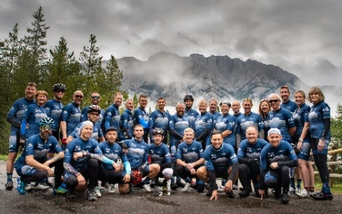
Mike Delaney has been here right from the start,  With Katie and the kids, they give all their heart  To make sure the riders have a great time,  It’s so good to see them here, making it nine!  Such a great family man is hard to find,  And he keeps his family active all the time. | 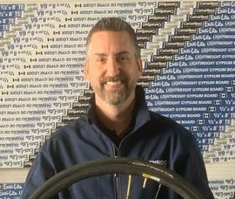
Marty Smith with his awesome big smile,  Is another that has been here all the while.  A great ambassador for the RTTR ride,  Encouraging others and fundraising with pride.  He tells how it’s changed his life for the best,  A lot better fitness and a lot less stress. | 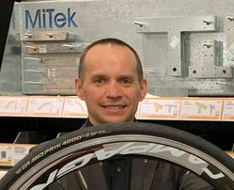
Toni, my wife, my coach and my best friend,  Has always stuck by me right to the end.  An amazing woman as you all can see,  Without her by my side I don’t know where I’d be.  Cycling, hiking, walking, skiing and weights,  There are not many seniors that have what it takes.  Me at 75, Toni at 74,  We just can’t help coming back for more. | 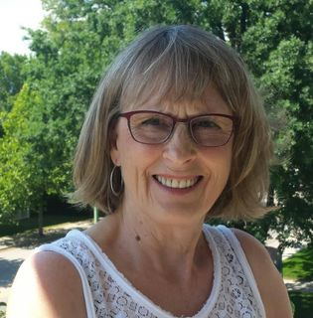
Mike Saunders, one of Qualico’s best,  Every year, puts the “A” group to the test,  To try and stay with him out on the road,  Goes by the handle “The Real Saunds” you know.  At RTTR there is nothing he lacks,  He is always near the front of the pack. | 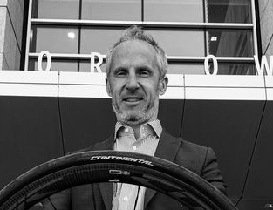

P2
Howard Sangwine is always the best,  At raising more money than all of the rest.  He brought RBC on as a sponsor,  A huge thank you from all of us, is our answer.  Six RTTR’s and over 6,000 k last year,  I’d say that we all owe him a beer. | 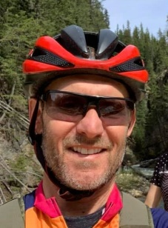
Joel Souchotte, a Qualico man and such a great friend,  Came back last year from his injuries, to attend  RTTR 2021 and rode like he was never gone.  We wish him and his family good health from now on. | 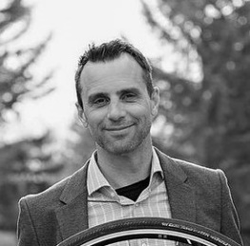
Sasha Petrovic stands out from the rest,  His big personality is one of the best.  Rode over 7,000 k in 2021,  No doubt there are many more k’s to come. | 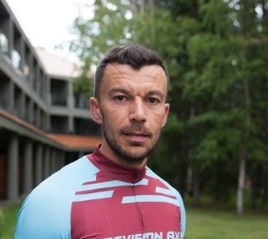
Yan Shedrick, project director, cyclist and cook,  At “camp” is always put on the hook  To put on a Michelin “5 star spread”  And keep all the hungry riders fed.  He loans us his trailer every year,  To help all of us transport our gear.  Count me in as his biggest fan,  What would we ever do without Yan? | 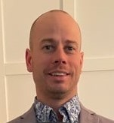
John Daniels didn’t know that all it would take,  Was to invite Ken to “Ride Around the Lake”  To get him to organize RTTR,  And in 8 short years bring it this far.  As two of the oldest, John and I try hard,  To ride with the “Boys”, and not play the age card.  I’m proud to call John my best friend,  And look forward to riding with him again. | 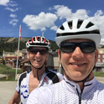

P3
Nicole Younge is an estimator at Star,  Has ridden RTTR six times so far.  I don’t know how she gets it done,  Her cycling training is next to none. | 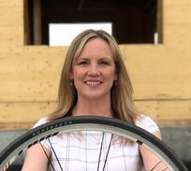
Shaun Younge the quiet unassuming type,  Doesn’t get involved in all the hype.  Rides to support charities of many kinds,  Like Nicole, has done RTTR six times. | 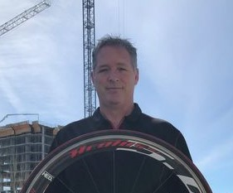
Dave Rogers with 5 rides, Sue Anderson with two,  Finally got to try something new;  Ride together at RTTR last year,  These two are an inseparable pair.  Dave is an artist and Sue is a nurse,  We hope that there will be more than this first. | 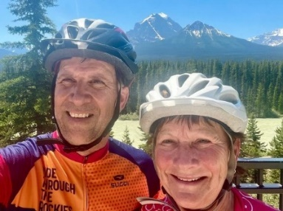
David Eggerman another Qualico man,  Lives in Winnipeg, and does what he can  To support RTTR and Ride Around the Lake.  One of our strongest riders, make no mistake.  Another one of those high mileage guys,  When he’s out on his bike he definitely flies. | 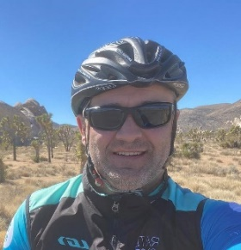
Peter Kozak Regional Director at Metrie,  Is also into skydiving extreme,  Look up in Canmore at Ha Ling Peak,  You might see him jumping any day of the week.  He should find cycling a bit boring it would seem.  But he’s out there anyway supporting the team.  Great to see him recovering from his crash. | 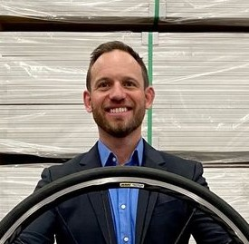

P4
Mark Wandy joined us 2017,  What an amazing progression it has been.  I remember his first ride up Highwood pass,  Wondering if he would run out of gas.  Born in Saskatchewan with the wind and its chills,  Moved to Kelowna, BC for the hills.  Rode almost 10,000 k last year,  And now he is one the one’s to fear. | 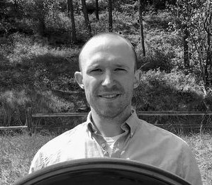
Geoff Keats has done half of the rides,  Pretty good rider and super nice guy.  Still looking for ways to improve,  Life of the party, always in a good mood.  Loved riding with him, but in the end,  I just want him to be my friend. | 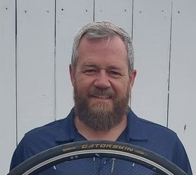
Gilles LePage has a dual role to play,  The mechanic who gets our bikes ready each day.  And then, if there’s time when he looks after us all,  He quickly gets his own bike ready to roll.  Such a great guy that all of us like,  But you better watch out, he’s a beast on the bike. | 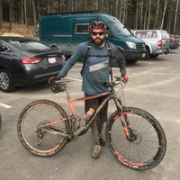
Liz Kovach from Winnipeg bubbly and bright.  With a beaming smile, greets everyone in sight.  She’s fun to ride with and strong on the bike,  A person that is very easy to like. | 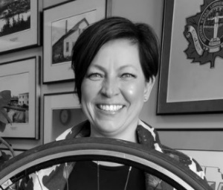
Vince Baraniecz a supplier top exec,  Thought, I’ll join RTTR, what the heck.  So, in 2019 there he was,  Supporting a very worthwhile cause.  If you’re wondering if he had fun at this “race”,  Just look at the beaming smile on his face. | 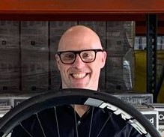

P5
Cam Grace is an aspiring rancher,  And is looking for his next adventure.  In 2019 he joined RTTR,  I’d say that he doesn’t need to look very far. | 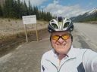
Bryon Howard, the racing realtor, has shown,  That for not only RTTR cycling he’s known.  Add running and swimming to the test,  As a triathlete he’s one of the best. | 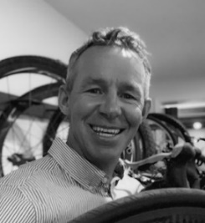
Vincenzo Fabiano, his name says it all,  When asked to join RTTR, he answered the call.  With big personality and clothes to match,  Definitely qualifies him as a good catch.  15,000 k last year he rode,  Listen to this, your mind will be blow’d.  Just counting the 100k rides, he did  44 since April, that’s second to none.  Those 44 rides totaled 6500k,  That’s 150k average per day! | 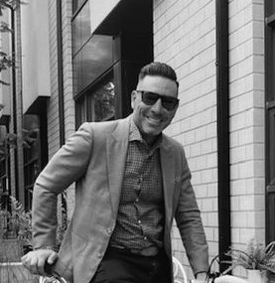
Sheila Carr back for her second RTTR ride,  Determined to ride with the “B” group this time.  When I saw her out there, she was having fun,  Looks like this girl is no where near done. | 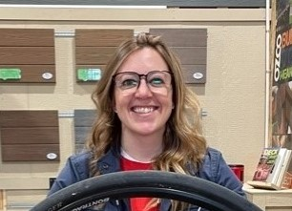
Chuck McKitrick, to Adrian about doing RTTR,  And this is his quote you’ve got to hear.  “What kind of muffin head would commit to that  kind of insane ride?”  “Good luck, amigo”  And then he decided to give it a try.  Cyclist, Swimmer, runner and all-round good guy. | 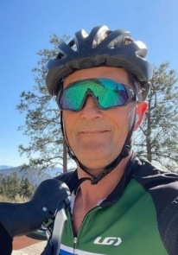

P6
Curt Keil bought his first road bike in May,  Joined RTTR, hope that he’s here to stay.  If he’s not on his bike he’s out on a run,  Which ever it is hope he’s having fun. | 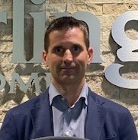
Michael Puhl last year did 10,000k on his bike,  When he’s not on his bike he’s out on a hike.  Rides at over 30 k per hour,  It’s all of those miles that gives him the power. | 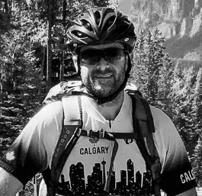
Adrian Rudzikas, IT guy that likes to ride,  Too many times he went sprinting by.  Maybe it was his way of trying to say,  You guys are too slow, get out of the way. | 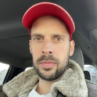
Kevin Brennan first timer at RTTR,  Got ready by riding 12,000k last year.  Partner at Build Studio Inc.,  He’s a shoe in for next year’s ride, I think. | 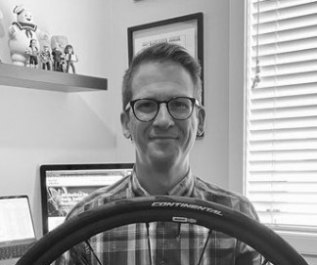
Some Epic Training Events From 2022 Season
RTTR cycling camp May long week-end Kelowna, BC. Ken Crockett, Marty Smith, Mark Wandy,
Kevin Brennan, Michael Puhl, Joel Souchotte, Yan Shedrick, Sasha Petrovic, David Eggerman,
Michael Finlayson, Jamie Walker, Geoff Keats and Willem Vandenberg rode over 500km
and climbed 8700 meters of elevation in 5 days.
Vincenzo Fabiano with an 800km 6500-meter week and his Summer Solstice 365km 3000-meter ride.
Oh, and he threw in a 120km 2000-meter gravel ride as well.
John Daniels got a little crazy one day in June and did a 110km 1600-meter gravel ride in the rain and mud in the mountains east of Kelowna.
Gran Fondo Badlands, Drumheller, June 25th 2022 we were well represented by;
Jamie Walker 3rd, Kevin Brennan 5th and Michael Puhl 7th overall.
Okanagan Gran Fondo, Penticton, July 10th 2022. Jamie Walker 50th O/A, Mark Wandy 53rd O/A,
Marty Smith, Mike Puhl and Yan Shedrick 83rd O/A, Sasha Petrovic 184th O/A,
John Daniels 295th O/A out of 1500 riders. Ken was right there until his Diabetes said stop.

P7

I’d also like to recognize our many valued Volunteers

Helen Smith controller at Star,
Has controlled RTTR pretty decent so far.
At organizing, delegating and fashion she’s strong,
Always makes sure that nothing goes wrong.
With Jaimie, Jason, and LeeAnne, what a dream,
Ken has put together an all-star team.

LeeAnne Alexander for 4 years so far,  Has helped plan, organize and run RTTR.  Manager of volunteer services for Habitat,  Volunteer lead, aid station and stuff like that. | 
Jaimie Firlotte is new to the group,  So it’s my job to give you the scoop.  As marketing coordinator, there’s no detail too small,  I’d like to thank her for looking after us all.  Some of us drove her crazy to no end,  She is now considered RTTR’s best friend. | 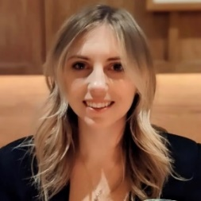
Jason LeBlanc is an IT guy,  And he handles things pretty well on the fly.  Crew chief at RTTR last year,  We can count on him being here year after year. | 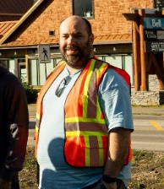
Jeff Laidlaw Star Building Materials salesman,  Every year helps out wherever he can.  Always in a helpful mode,  Looking after lunch and last rider on the road. | 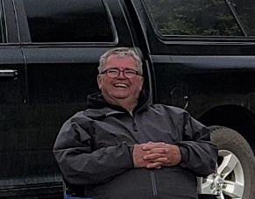
Derek Resler Star Builders outside sales rep,  Spends most of the ride as our lunch food prep.  Has what I consider the number one role  Providing all of us soup for the soul. | 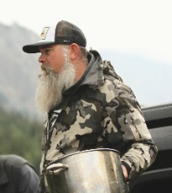
P8  Mike O’Brian Habitat for Humanity volunteer,  Drove the van for us a few years.  A man with so much patience is hard to find,  To all of us Mike was one of a kind. | 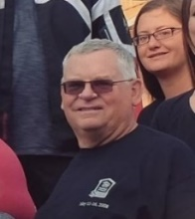
Massage Therapists, oh what a treat,  Fixing our aches from our heads to our feet.  David Rubenfeld started it all,  Since then, many have answered the call.  Tanya Gladue, Erin Vincent, Lindsay Rolfsen  and Rachael Lehr. | 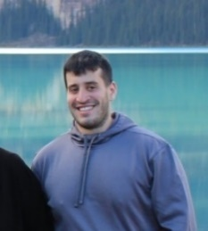

And a huge shout-out to our Photographers and Videographers.
They have captured the best moments of our event and we are able to relive them and
share the experience with others. We are grateful for their time and talent.
Ashley Williams – Director of Operations StreetSide Developments | Isolated Peak Photography
Christian Ravary – Qualico Safety Manager | Photographer
Maximilian Conrad – Marketing Professional | Photographer | Videographer | Animal Advocate
Past Riders
There is a sheet on your table listing all of
the riders that have participated in RTTR.

There are some who haven’t ridden for a while,
When we think of them it brings a big smile.
Each one helped in their own way,
To make RTTR what it is today:
Over 60 riders and countless volunteers have
supported RTTR since 2014.
I apologize to those that I have not included.
Everyone that has ridden in RTTR has added to it’s
success and support of Habitat for Humanity.
You all deserve a little attention,
To each of you I give Honorable Mention.

P9
To the Wives, Husbands, significant others and families
You mean as much to RTTR and Habitat
As all of the riders, no doubt about that.
You may not realize the role you play
In supporting the riders that feel this way.
Without your encouragement and support,
There would be no RTTR success to report.
New Riders Welcome to RTTR 2022
It won’t take long for you to see
That this special group is one big family.
From training rides, bike camps, fundraising and more
It will no doubt get you excited for more.
And Kenneth, as he’s known to his dad and mom,  At whatever he does is second to none.  Ken, you make mom and I proud,  And now, I get to say it out loud.  A wonderful son, husband, father and friend,  You will be in everyone’s heart ‘til the end.  With all of your passion, commitment and heart,  You have made RTTR a huge hit from the start.  An outstanding event that has lasted 9 years,  For all that you’ve done we give you 3 cheers,  Everybody please join me…  Hip Hip Hooray! Hip Hip Hooray! Hip Hip Hooray! | 